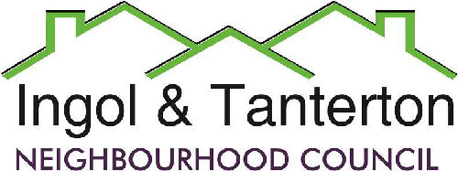
Gill Mason - Clerk and RFO
Email: ingoltantertonnc@hotmail.co.uk

Agenda
A meeting of the Ingol and Tanterton Neighbourhood Council Events Committee will be held on Wednesday 1st October 2025 7pm at Tanterton Village Centre.

1.To receive apologies.

2.To receive declarations of interest and dispensations.

3.Public participation.

4.To consider the arrangements for the Christmas Light Switch on event.
- Date of event
- Correspondence with Methodist Church
- Budget for refreshments and section boxes
- School invitations
- Date for Christmas tree and fence siting.

Press and public are welcome to attend.

